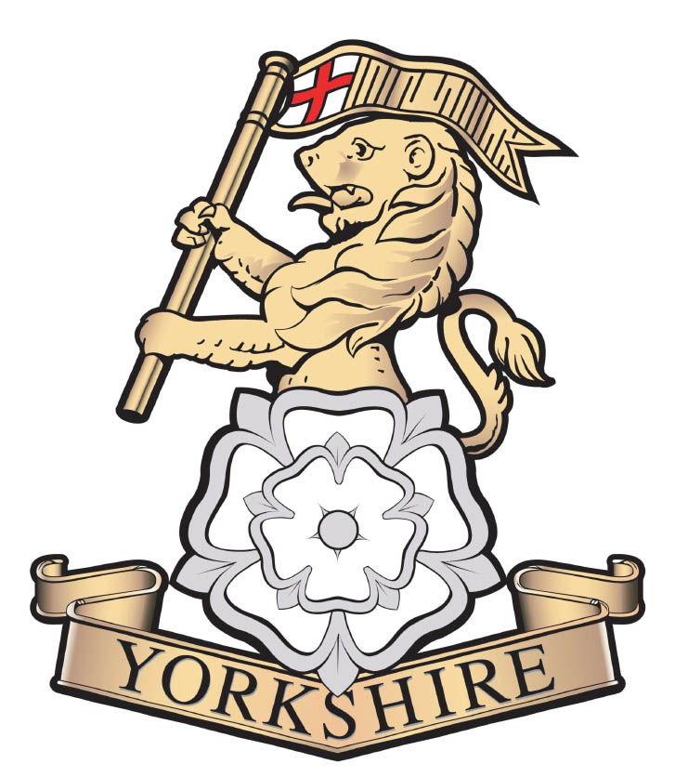 |  | Regimental Headquarters  The Royal Yorkshire Regiment  3 Tower Street  YORK  YO1 9SB  Telephone: 0300 164 3299  Email: rhq@yorkshireregiment.com

YORKS/1/4

See Distribution 21st April 2023

THE ROYAL YORKHIRE REGIMENT - CONSEQUENTIAL CHANGES

Reference:

- The Regimental Handbook, Edition 3, dated Jun 21.

1. It is important, in order to ensure credibility and consistency, that certain rules and disciplines are laid down regarding the use and exploitation of the ‘Royal’ title. This note directs changes to Ref A and are to be implemented as soon as practical. These should be adhered to by all constituent parts of the Regiment.

2. Titles. The following are the new titles to be used:

- The Regimental Title – The Royal Yorkshire Regiment (14th/15th, 19th and 33rd/76th Foot)

- Regimental Abbreviation – R YORKS

- Regimental Headquarters – Regimental Headquarters, The Royal Yorkshire Regiment

- Regimental Headquarters Abbreviation – RHQ R YORKS

- Unit Titles –

1st Battalion The Royal Yorkshire Regiment (note: no comma and capital T)
2nd Battalion The Royal Yorkshire Regiment
4th Battalion The Royal Yorkshire Regiment

- Unit Abbreviations –

1 R YORKS (note the spacing)
2 R YORKS
4 R YORKS

3. Correspondence. With immediate effect, all letter headings, email signature blocks, Compliment Slips, Business Cards, Invitations and other forms of regimental written correspondence are to be amended or reproduced to include the word ‘Royal’ in the title.

4. Signboards. All battalion signboards, especially those positioned at camp entrances, are to be amended or reproduced to include the word ‘Royal’ in the title; It is anticipated that this can be done locally, at no cost to the Regiment; however, if this is not the case, please advise RHQ. Please see Ref A, p98 for guidance on design.

5. Social Media. All the landing pages have been changed to reflect the new title; not all the addresses have been changed:

Facebook – @RYORKSRegt
Instagram – @yorksregt
Twitter – #RYORKS_REGT

6. The Colours. The Colours will not be changed until the due time (c.2030). The new ones will be Royal Blue. The 8 x regimental Colour Belts will all need to be changed, but not until after the Coronation, and this will happen over time.

7. Loyal Toasts. The current practice, as laid down in Ref A pp 40-41, of toasting ‘The King’ and ‘The Regiment’ will remain extant until a new Colonel in Chief is appointed.

8. Dress.

- There will no change to the regimental capbadge, collar dogs, TRFs or flags
(Bn or Coy).

b. Changes to regimental patterns of dress are still being staffed and therefore more detailed information will be promulgated separately. In the interim please note the following intent:

- No.1 Dress Hats – officers and soldiers will wear a Royal Pattern No1. Dress Forage Cap. Approval has been sought, and is anticipated, from the Army Dress Committee. Therefore for now, those involved in Op GOLDEN ORB should prepare as follows:

- Officers may either choose to pay for their own replacement headdress via accredited regimental tailors (@ c.£215) or have them altered at regimental expense (@ c.£20).

- For soldiers, QMs should demand through normal G4 channels. See Annex A for details.

- Rank Slides / Shoulder Titles – new Rank Slides and Shoulder Titles are being scoped; these would be issued to all serving personnel but are not expected to be available until late summer. The current pattern should be worn until any new one is in circulation.

- Staple Belts – new Staple Belts are being scoped; these would be issued to all serving personnel but are not expected to be available until the autumn. The current pattern should be worn until any new one is in circulation.

- Sports Kit – new sports top / T Shirts etc will henceforward be procured with ‘R YORKS’; this change will happen incrementally.

9. Costs. Individuals are not expected to fund any changes themselves.

10. Regimental Handbook. Although normally only subject to a major revise every 5 years, this will be undertaken to incorporate all amendments so affected by the Royal title. In the meantime, the current Version 3 remains extant on all other issues and remains available on the website at YORKSHIRE REGIMENT HANDBOOK.

Fortune Favours The Brave

DRE O’Kelly

D R E O’KELLY
Lieutenant Colonel
Regimental Secretary

Distribution:

Regimental Bord
Regimental Trustees
1st Battalion }
2nd Battalion } for CO, Adjt, QM, RSM
4th Battalion }
Regimental Chaplain
Serving Pers at ‘E’
HQ Cleveland ACF
HQ Yorkshire (N&W) ACF
HQ H&SY ACF
RHQ R YORKS – for all staff

Copy:

Former Cols Regt
Chairman RYRA

Annex A to
RHQ R YORKS 1/4
Dated 22 Apr 23

No.1 Dress Forage Cap

