From: Major MP Lynch |  | Assistant Regimental Secretary
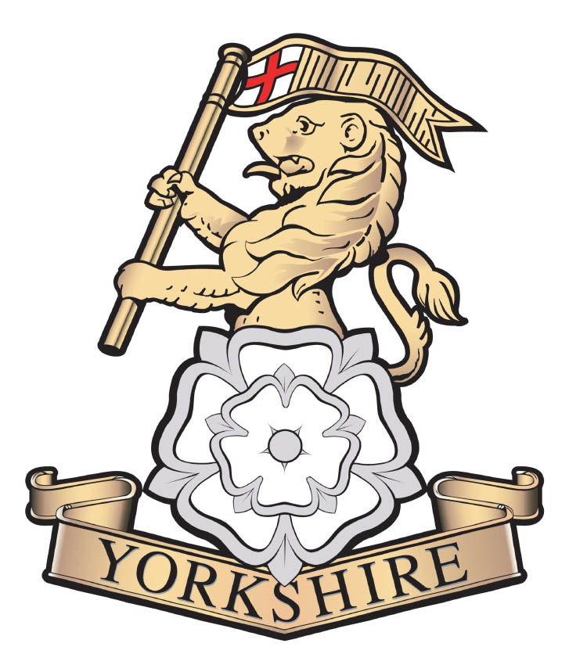 |  | The Yorkshire Regiment  Trinity Church Square  RICHMOND  DL10 4QN  Telephone: 07943 612521  Email: AHQNorth@yorkshireregiment.com

9 Jan 23

THE YORKSHIRE REGIMENT ASSOCIATION
ANNUAL GENERAL MEETING SATURDAY 4 MAR 23

The Yorkshire Regiment Association, Annual General Meeting will take place on Saturday 4th March 2023 in the Hilton Hotel, 1 Tower Street, York, YO1 9WD, next to YORKS RHQ.

Reception will open at 1000 with free tea and coffee, the AGM will start at 1030 and will be followed by a free buffet lunch at 1300. On completion of the AGM and lunch there will be an opportunity for all members to move into York for an informal social gathering.

Attendees are requested to complete the short registration form accessed via this LINK – the registration form can also be accessed via the QR code at the end of this letter. Note that in order to confirm catering requirements and numbers you are requested to register no later than Friday 10th February 2023.

The minutes of the Executive Committee meeting which took place on 3 Dec 22 and draft agenda for the AGM have been distributed together with this calling notice, anyone who would like to suggest any agenda items can do so via the registration form linked above or by e-mailing the undersigned.

The AGM is open to all branches of the YRA, branches of the antecedent associations, independent members and the three Battalions; this is your opportunity to shape the future focus and direction of the YRA and I look forward to seeing you all in March.

Mick Lynch

YRA Chair

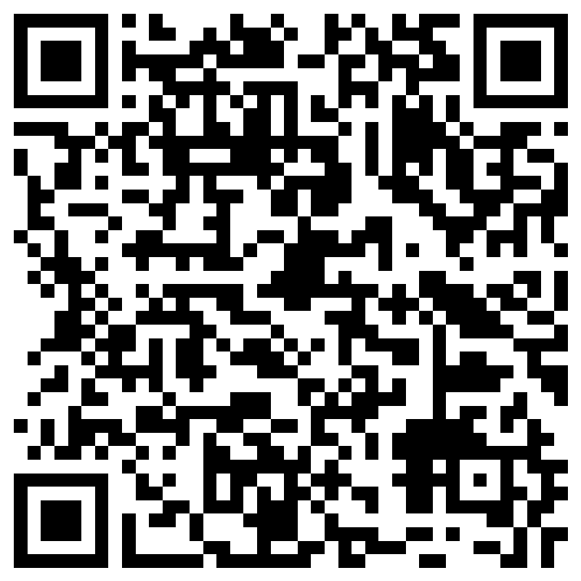
Distribution:

Colonel of the Regiment - President YRA
RHQ The Yorkshire Regiment
1st Bn The Yorkshire Regiment
2nd Bn The Yorkshire Regiment
4th Bn The Yorkshire Regiment
Chairman YRA
PWO Association
GH Association
DWR Association
YV Association

